HOW TO SET YOUR OUT OF OFFICE MESSAGE IN AXIGEN

Log into the account in Axigen.
On the lower left hand corner, there is a little GEAR for settings. Click that, and click SETTINGS.

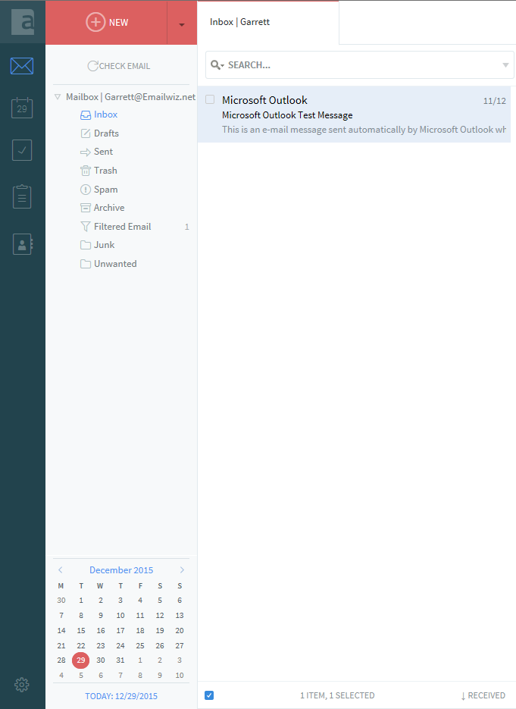

On the GENERAL TAB, you will see the OUT OF OFFICE responder option, where you just click it and put in the dates and a message. Enter the information and click SAVE AND CLOSE.

